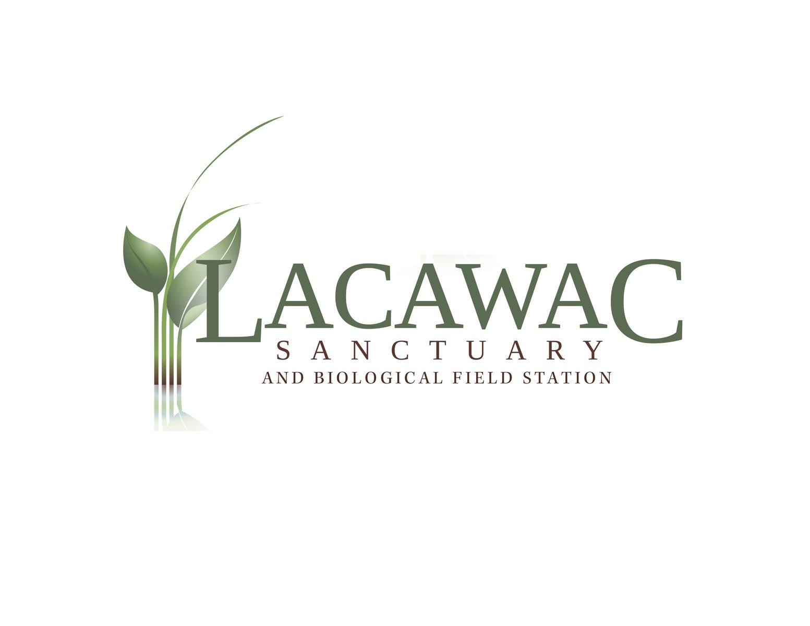

Camp Counselor Application

Day Camp 2018

Name: | Date:
Address:
Phone:
E-mail:

Are you a citizen of the United States? (circle one) Yes No

If not, do you have the right to work in the United States? (circle one) Yes No

Have you ever been convicted of a crime? (circle one) Yes No

If yes, please state offence(s), date(s), and location(s). A conviction record will not necessarily be a cause for disqualification.

Education

 | Highest Grade Completed | Course of Study | Diploma Received
High School
College
Vocational School
Do you have any additional courses or training you would like us to know about?

Previous Employment and References
Please list all previous employers, starting with current or most recent.

Employer name, address, and phone number: | Position and responsibilities:
 | Supervisor’s name:
 | Dates Employed:
 | Reason for leaving:

Employer name, address, and phone number: | Position and responsibilities:
 | Supervisor’s name:
 | Dates Employed:
 | Reason for leaving:

Employer name, address, and phone number: | Position and responsibilities:
 | Supervisor’s name:
 | Dates Employed:
 | Reason for leaving:

Please answer the following questions: (use additional space as needed.)

Why do you feel you are the most qualified candidate for the position of Camp Counselor?

What age group do you prefer to work with and why?

What is the most important quality a camp counselor should have and why?

Describe any experiences or training you have working with children.

Describe any experiences you have teaching or learning about the environment.

Describe any experiences or training you have in a leadership position.

Please list any certifications in lifeguarding, CPR, First Aid, as well as expiration dates:

Please rate your knowledge and experience based on the following scale:
1: No knowledge 2: Very little 3: Understand basic 4: Somewhat 5: Can train or teach this knowledge concepts knowledgeable subject

Fire building: | Crafts: | Icebreakers:
Hiking: | Nature journaling: | Group Games:
Wildlife Study: | Environmental Art: | Local History:
Survival Skills: | Journal Making: | Canoeing:
Pond Ecology: | Forest Ecology: | Camp Songs:

Please list three references (not related to you) who have seen you work with children

Name: |  | Relationship:
Phone: |  | Years known:
Name |  | Relationship:
Phone: |  | Years known:
Name |  | Relationship:
Phone: |  | Years known:

Complete and Return to:
Lacawac Sanctuary and Environmental Education Center
Attn: Jamie Reeger
94 Sanctuary Road, Lake Ariel, PA 18436
Email: jamie.reeger@lacawac.org
Phone: (570) 689-9494
