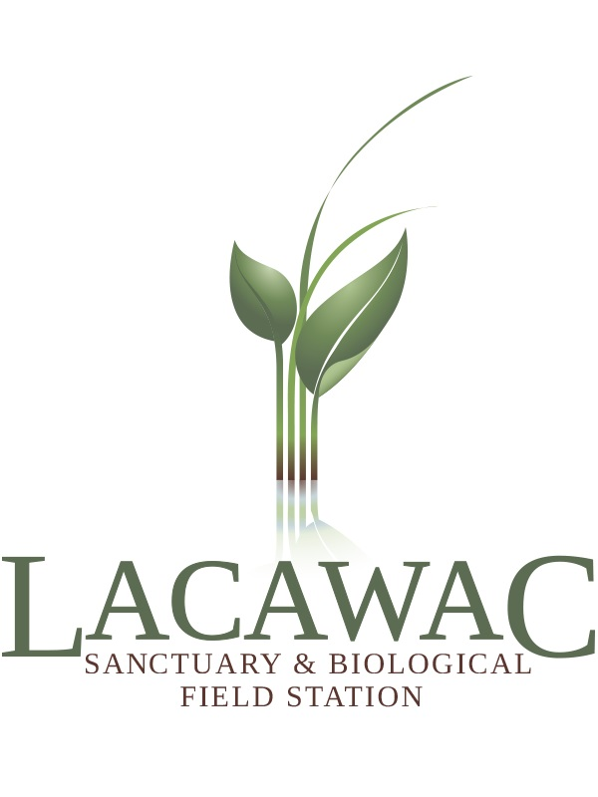
Workshop on Ecological Functional Genomics

May 24 – 26, 2017
Lacawac Sanctuary & Field Station, Lake Ariel, PA

Application Deadline: April 14, 2017

This two-day workshop will introduce ecologists and evolutionary biologists to computational methods for the comparative analysis of genome sequences. Topics discussed will include finding homologous sequences within a genome and in other species, gene family construction, multiple sequence alignment, phylogenetic tree reconstruction, analysis of gene duplication and loss, and tests for selection in protein-encoding genes. The workshop is intended to enable researchers to ask and answer questions in molecular ecology, such as those focused on genetic underpinnings of phenotypic diversification. The first day of the workshop will have lectures on these various topics, with the second day presenting an opportunity for students and researchers to work with their own datasets together with course instructors.

Target Audience: The Workshop on Ecological Functional Genomics is designed for undergraduate and master’s level students that are prepared to apply the acquired knowledge in ongoing or future projects.

Prerequisites and computer requirements: Prior bioinformatics experience is desirable, but not required. If selected for this workshop, you will be required to bring your own laptop computer with wireless internet capacity.

Instructors:

Dr. Ananias Escalante, Department of Biology and Institute for Genomics and Evolutionary Medicine, Temple University

Dr. David Liberles, Department of Biology and Center for Computational Genetics and Genomics, Temple University

Dr. Liang Liu, Department of Statistics and Institute of Bioinformatics, University of Georgia

Dr. Stephanie Spielman, Department of Biology and Center for Computational Genetics and Genomics, Temple University

Laurel Yohe, Department of Ecology and Evolution, Stony Brook University

Lodging: Overnight housing will be provided at the Historic Watres Lodge at Lacawac Sanctuary on 24-25 May 2017. Space is limited for private rooms; most of Lacawac lodging facilities are shared rooms. Restrooms/bathrooms are shared by lodging guests. Linens, blankets and towels are provided. Alternative lodging may be available at the Comfort Inn Pocono Lakes Region (~8 miles from Lacawac Sanctuary). To book a room, contact the hotel directly.

Comfort Inn Pocono Lakes Region
117 Twin Rocks Road
Lake Ariel, PA 18436
(570) 689 4148

Travel: All participants are required to organize their own travel. Lacawac Sanctuary is 130 miles outside of Philadelphia and 100 miles from New York City.

Closest airport: Wilkes-Barre/Scranton International Airport, Avoca PA (~35 miles from Lacawac Sanctuary)

Participants accepted to this workshop should plan to arrive to Lacawac Sanctuary by the evening of 24 May and depart after lunch on 26 May. Lodging is available on 26 May for an additional $30/night.

Scholarships: A limited number of scholarships are available to cover accommodations, registration, and food. All participants are responsible for travel costs. Scholarship applicants must be research active undergraduate students. To apply, please send the following in addition to the application to daliberles@temple.edu: a brief statement indicating why you’re attending the workshop, how you will benefit from taking it, and what you hope to gain. Clearly outline your academic training and career path.

Application for Workshop on Ecological Functional Genomics 2017:
Please submit this application and CV as a single pdf to sarah.princiotta@lacawac.org.

Name: ____________________________________________________________________________________

Institution/Organization: _____________________________________________________________________

Department: _______________________________________________________________________________

E-mail: ___________________________________________________________________________________

Phone: ____________________________________________________ (Please circle: Mobile, Office, Home)

Background Information:
Professional Status:
___ Undergraduate Student
___ Graduate Student
___ Research Scientist

Undergraduate Institution: ____________________________________________________________________
Years Attended: ______________________________________ Degree: _______________________________

Graduate Institution: ________________________________________________________________________
Years Attended: ______________________________________ Degree: _______________________________

Briefly describe your background and experience in bioinformatics/programming:

Will you be bringing a dataset for analysis? If yes, please describe.

Briefly describe your overarching research question.

Please list any food allergies/dietary restrictions so that we can accommodate your needs:
____________________________________________________________________________________________________________________________________________________________________________________

FEES:
____ $60 for lodging 5/24 – 5/25
____ Check here if you are interested in lodging on the sleeping porch.
____ $30 for additional overnight lodging on 5/26 (optional)
____ $170 registration + all meals (required for all participants)

_____ TOTAL FEES

PAYMENT OPTIONS:
You will not be charged until accepted to the workshop.

Check: Make payable to Lacawac Sanctuary and mail to: Sarah Princiotta, Lacawac Sanctuary, 94 Sanctuary Road, Lake Ariel, PA 18436.

Credit card: ____ Visa ____ MasterCard ____ Discover ____ American Express
Please charge the following credit card number in the amount of $____________
Name on credit card:_________________________________________________________________________
Billing address:_____________________________________________________________________________
City: _______________________________________________ State: ____________ Zip: ________________
Acct number:________________________________________ Exp. Date: _______ / _______ CVV:_______
Signature:_____________________________________________________ Date:_______________________

Cancellation policy: The last day to cancel for a full refund is May 14, 2017.

Contact Sarah Princiotta, Director of Research and Education with any questions: sarah.princiotta@lacawac.org or 570-689-9494. If accepted, you will be notified by the first week of May 2017.

