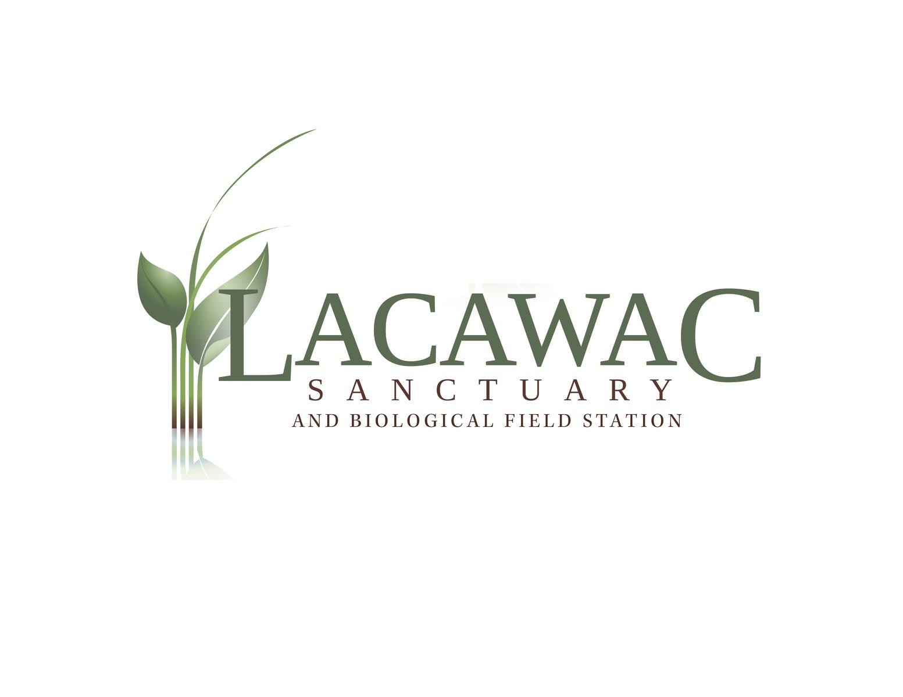

Junior Counselor Application

Day Camp 2018

Name: | Date:
Address:
Phone:
E-mail:
Education:
School: Grade Completed as of 6/2018:

Are you a citizen of the United States? (circle one) Yes No

If not, do you have the right to work in the United States? (circle one) Yes No

Have you ever been convicted of a crime? (circle one) Yes No
If yes, please state offence(s), date(s), and location(s). A conviction record will not necessarily be a cause for disqualification.

Please list three references who have seen you work with children:
Name: |  | Relationship:
Phone: |  | Years known:
Name |  | Relationship:
Phone: |  | Years known:
Name |  | Relationship:
Phone: |  | Years known:

Please answer the following questions: (use additional space as needed.)

What interests you about volunteering at Lacawac as a junior counselor?

What age group do you prefer to work with and why?

What is the most important quality a camp counselor should have and why?

Describe any experiences or training you have working with children.

Describe any experiences you have teaching or learning about the environment.

Describe any experiences or training you have in a leadership position.

Please list any certifications in lifeguarding, CPR, First Aid, as well as expiration dates:

Please rate your knowledge and experience based on the following scale:
1: No knowledge 2: Very little 3: Understand basic 4: Somewhat 5: Can train or teach this knowledge concepts knowledgeable subject

Fire building | Crafts | Icebreakers
Hiking | Nature journaling | Group Games
Wildlife Study | Environmental Art | Local History
Survival Skills | Journal Making | Canoeing
Pond Ecology | Forest Ecology | Camp Songs

Please check the weeks you are available to volunteer.
You must commit to at least 2 weeks of camp:
- Creature Feature 1: (Ages 5 & 6) July 2-6
- Creature Feature 2: (Ages 5 & 6) July 16-20
- Exploring Nature: (Ages 7-8) July 23-27
- Eco Investigators: (Ages 9-10) July 30-Aug 3
- Wilderness Adventures: (Ages 11-12) Aug 6-10
- Earth Expressions Art Camp: (Ages 8-10) July 9-13

Complete and Return to:
Lacawac Sanctuary and Environmental Education Center
Attn: Jamie Reeger
94 Sanctuary Road, Lake Ariel, PA 18436
Email: jamie.reeger@lacawac.org
Phone: (570) 689-9494
