0  Volunteer Application  Name:  __________________________________  Address:  __________________________________  City: ______________________________  State: _______________ Zip: _________  Phone: ____________________________  E-mail:  __________________________________  Days of Week and Times Available:  __________________________________  Any Specialized Training:  __________________________________  Volunteer Opportunity Interested In:  __________________________________  __________________________________  Mail Application to: Lacawac Sanctuary, 94 Sanctuary Road, Lake Ariel, PA 18436  Email: stewardship@lacawac.org  Fax: 570-689-9494 |  | For More Information Contact  Joseph Princiotta  Stewardship/ Volunteer Manager  stewardship@lacawac.org  For Internships Contact  Dr. Sarah Princiotta  Director of Research and Education  sarah.princiotta@lacawac.org  General Contact Information  94 Sanctuary Road  Lake Ariel, PA 18436  info@lacawac.org  570-689-9494 |  | Lacawac Sanctuary  - Volunteer Opportunities

Why Volunteer  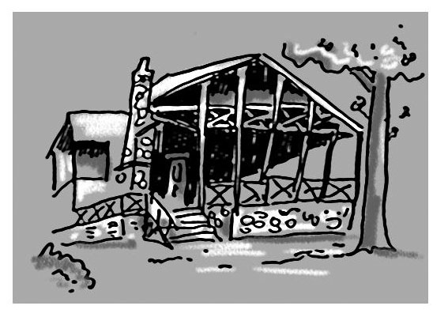  Volunteers are the bread and butter of Lacawac. Since the 1970’s, thousands of hours have been spent on habitat restoration, fundraising, education, research and all through the efforts of volunteers. If you are willing to meet new people, have a lot of fun, and help Lacawac grow, then our volunteer program is for you. |  | What Opportunities Are Available  Environmental Programs and Education  - Nature Walk Leaders  - Lacawac Historical Tour Leaders  - Public Education Assistants  - Youth Education Programs  Nature Center and Grounds  - Public Relations Assistant  - Mailings and Distribution Assistant  - Trail Maintenance  - Native Plant Gardening  - General Building Maintenance  Technical  - Graphic Design and Technology  - Website and Social Media Maintenance  - Newsletter Assistant  Special Events  - Event Planning  Group Projects  Work as a part of an organized scout troop, school class, service club or other group. Complete one time projects. |  | Internships  Lacawac offers internship programs for undergraduate and graduate students interested in conducting ecological field research. Similar to the National Science Foundation’s Research Experiences for Undergraduates, interns work with scientific professionals, conduct and present original research, and gain valuable professional experience at a biological field station that has a rich history of launching prominent ecologists’ careers.  Internship programs are also available to high school students. Students studying marketing, public relations, history, and education can complete internships at Lacawac.  Community Service Hours  If you need hours to fulfill a school, club, organization or association requirement please email stewardship@lacawac.org with the number of hours needed, deadline for completing hours and when you would be available to volunteer.

